St. John Paul II Preparatory School Receives National Award for the CLT10
January 27, 2022

St. John Paul II Preparatory School
has been named one of the

Top 20 Schools in the Classic Learning Test
2021 National School Rankings

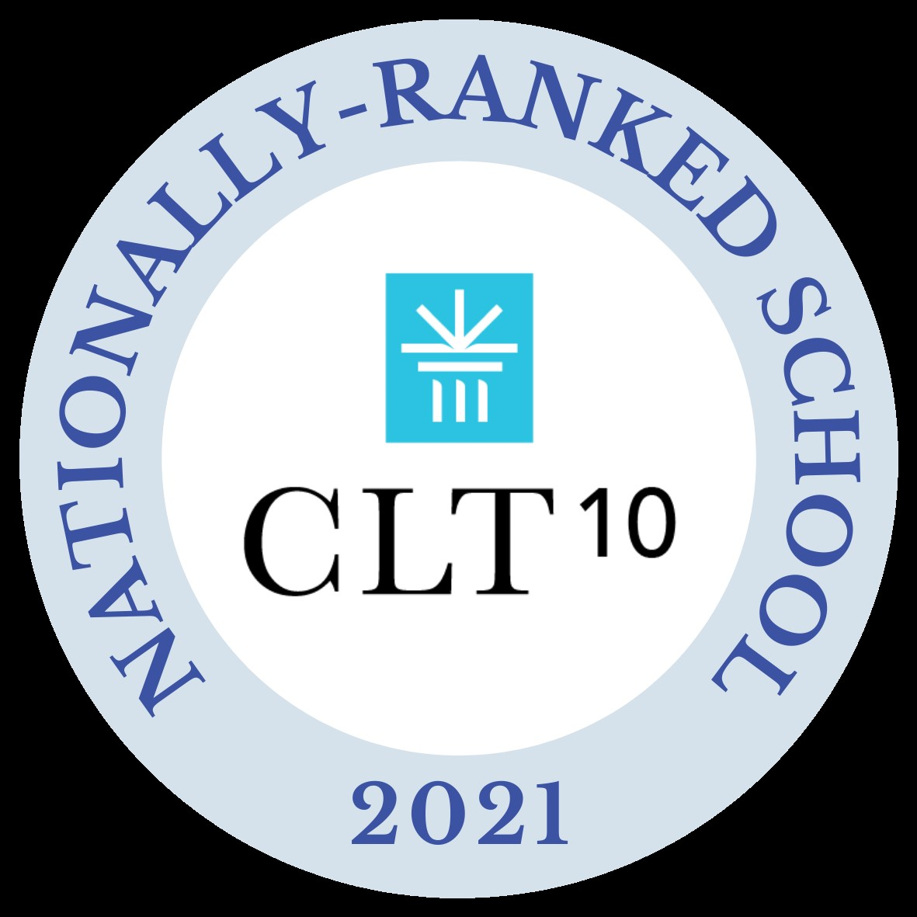

This award recognizes St. John Paul II Preparatory School’s student body for collectively receiving one of the highest median scores in the nation on the CLT10.

The CLT10 is a college preparatory exam and PSAT® alternative designed for 9th and 10th graders and offered by the Classic Learning Test. Evaluating English, math, and critical reasoning skills, it provides a comprehensive measure of achievement and aptitude and engages students with classical texts from the most influential authors across time.

Since its inception in 2016, Classic Learning Test has offered assessments steeped in more intellectually rich and rigorous content than other standardized tests. Out of the hundreds of schools that take the CLT10 every year, St. John Paul II Preparatory School is thrilled to receive this distinguished recognition and celebrate this remarkable achievement.

