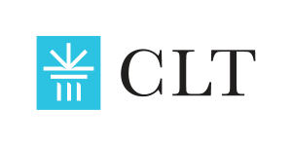
DISTINGUISHED SCHOLAR AWARDS
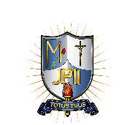
ST. JOHN PAUL II PREPARATORY SCHOOL

2019

Robert James Cupples
St John Paul II Preparatory School

2020

Benjamin Nack
St. John Paul II Preparatory School

Robert James Cupples
St. John Paul II Preparatory School

2021

Gabe Bell
St. John Paul II Preparatory School

2022

Anna Armesto
Saint John Paul II Preparatory School (Saint Charles, MO)

