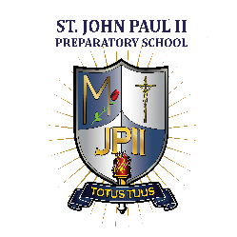
JPII proudly congratulates the following high school students named
MIDWEST REGIONAL SCHOLARS on the CLASSIC LEARNING TEST
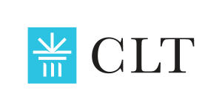

REGIONAL SCHOLARS 2023

Isaac Keys Bernard Forget

CONGRATULATIONS ON YOUR ACHIEVEMENTS!

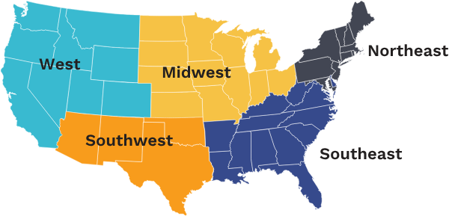
Regional Scholars scored in the top 5% in their geographic region.
The Classic Learning Test (CLT) is a college entrance exam for 11th and 12th graders. Accepted at hundreds of colleges across the US, the CLT is an alternative to the SAT® and ACT® and utilizes the greatest and most enduring texts that have informed and shaped society. CLT exams emphasize intellectual aptitude and achievement across the curricula.

