St. John Paul II Preparatory School Receives National Award for the CLT10
January 25, 2020
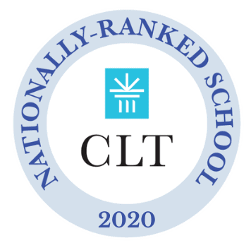
St. John Paul II Preparatory School has been named one of the Top 20 Schools in the Classic Learning Test’s 2019-2020 National School Rankings. This award recognizes
St. John Paul II’s student body for collectively receiving one of the highest median scores in the nation on the CLT10.

The CLT10 is a college preparatory exam and PSAT® alternative designed for 9th and 10th graders and offered by the Classic Learning Test. Evaluating English, math, and critical reasoning skills, it provides a comprehensive measure of achievement and aptitude and engages students with classical texts from the most influential authors across time.

Since its inception in 2016, Classic Learning Test has offered assessments steeped in more intellectually rich and rigorous content than other standardized tests. Out of the hundreds of schools that take the CLT10 every year, St. John Paul II Preparatory School is thrilled to receive this distinguished recognition and celebrate this remarkable achievement.

